**Task8, AWS Task3**

Launch an EC2 instance (Linux and Windows) along with a web server. Then, create an EBS volume of 5 GB, attach it to an EC2 machine (Linux and Windows), and take a snapshot. Finally, create an EBS volume using the taken snapshot.

**Step1:**

Prepare the Bash Script for launch the Linux instance with Apache

**#!/bin/bash**

**# Update the package list**

**sudo apt update**

**# Install Apache2**

**sudo apt install -y apache2**

**# Start Apache2 service**

**sudo systemctl start apache2**

**# Enable Apache2 to start on boot**

**sudo systemctl enable apache2**

**# Print the status of Apache2 service**

**sudo systemctl status apache2**

Prepare the PowerShell script for launch the windows instance with IIS server

**<powershell>**

**# Install IIS**

**Install-WindowsFeature -Name Web-Server -IncludeManagementTools**

**# Start IIS service**

**Start-Service -Name W3SVC**

**# Set IIS to start automatically on boot**

**Set-Service -Name W3SVC -StartupType Automatic**

**# Create a simple HTML file to verify the installationNew-Item -Path "C:\inetpub\wwwroot\index.html" -ItemType File -Value "<html><body><h1>IIS is running on EC2 instance</h1></body></html>"**

**</powershell>**

Launch an Instance🡪Select the OS🡪Network Setting🡪Advance Setting🡪User Data🡪

Upload the script, Bash for Linux and Powershell for Windows.

Linux:

Script for Launch the instance with Apache server

Windows:

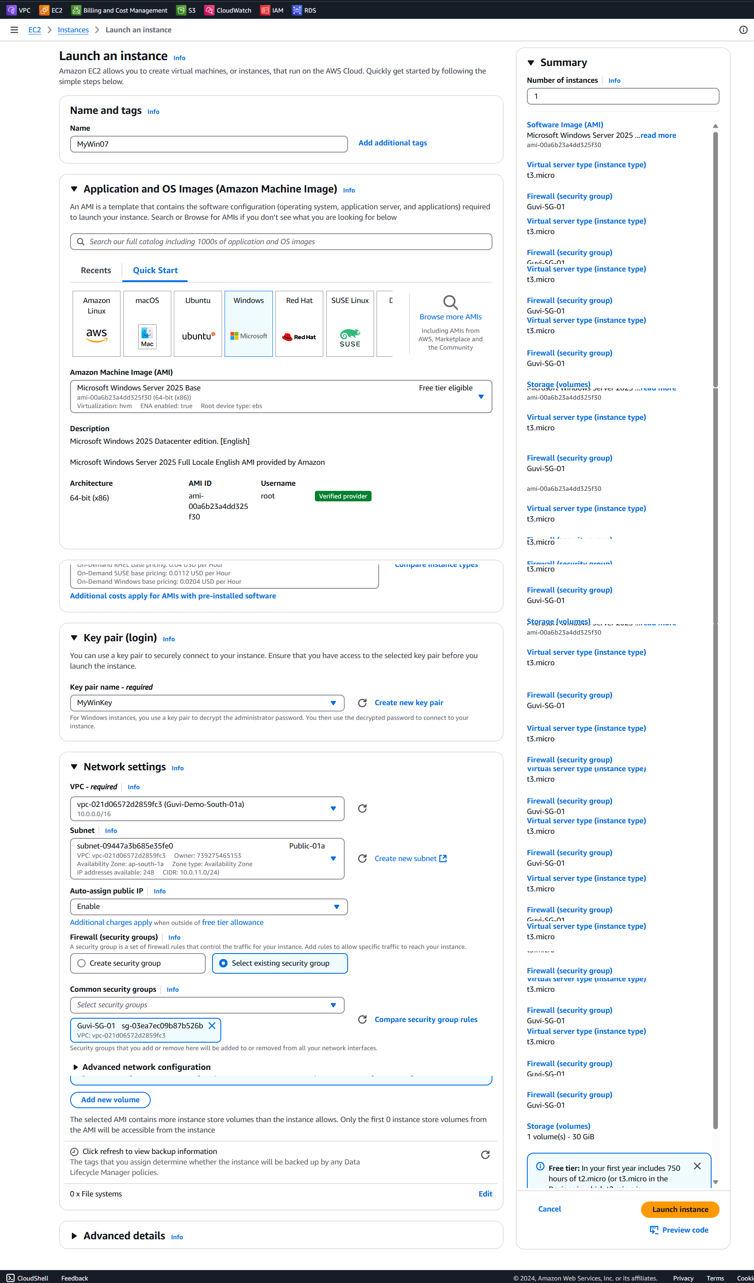

Step 2:

Launch the instance now.

Linux with Apache

Step 3: Add EBS

Attach Volume:

Add the attach the volume to Windows machine

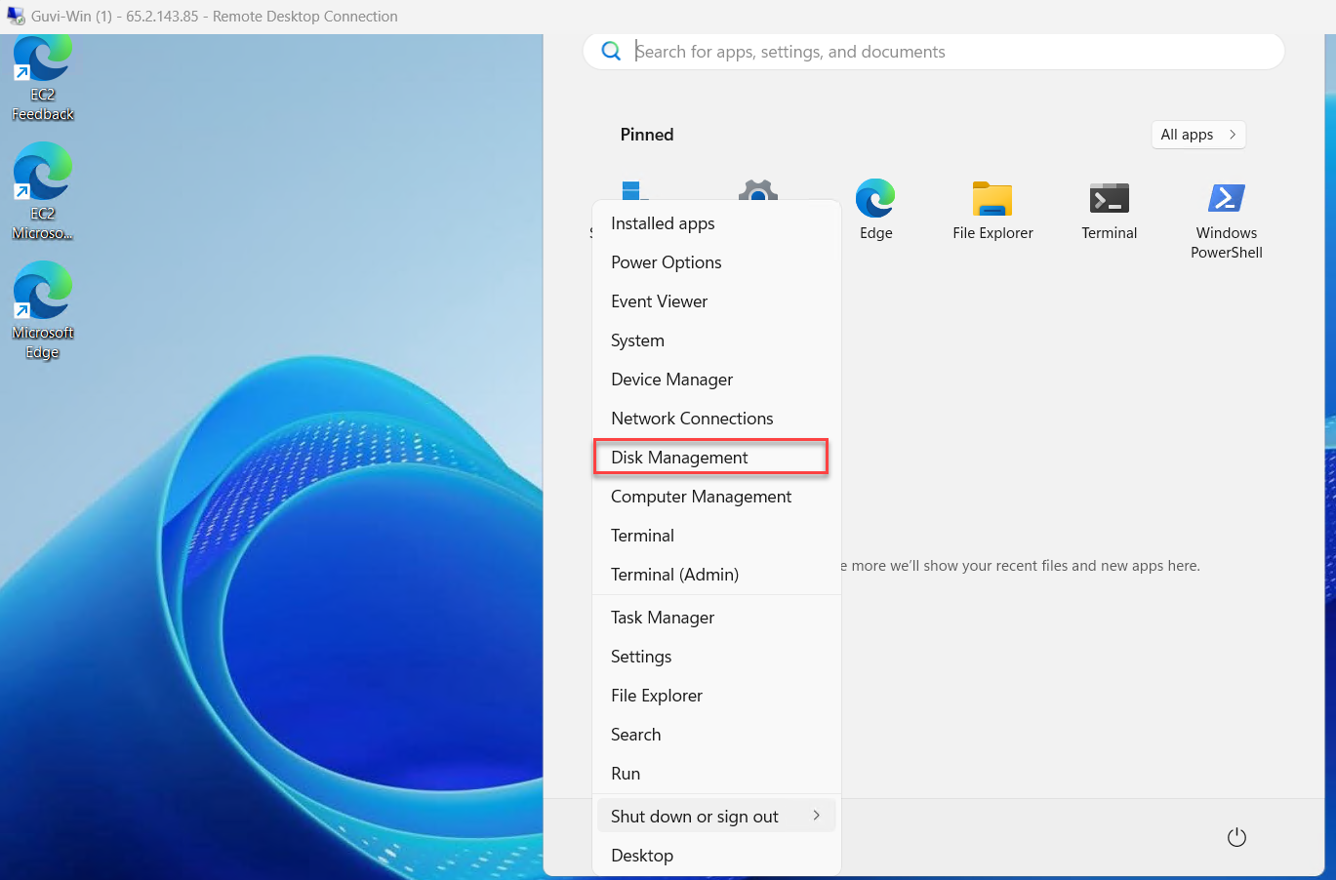

Attach the volume to Linux machine:

Create Snapshot:

Created Volume with snapshot, We can use it for other VMs:

Repeat the same steps for Linux Machine.